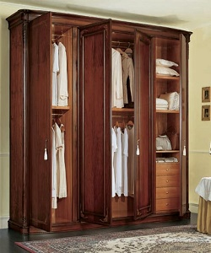

Unique Wardrobe

$163.39

Availability: In stock

Description

Modern wardrobe with 8 sections and side curved interior doors. This will gives a classy look to your room. The nature and design of this allows it to suit most modern bedrooms.